**Experiment 5**

Aim: To implement dimension tables and fact tables using SSMS.

Steps:

Step1: Open SSMS and restore database (option visible when right-clicked on databases

option). Then click on the (…) option in the right corner side and add the BAK file.

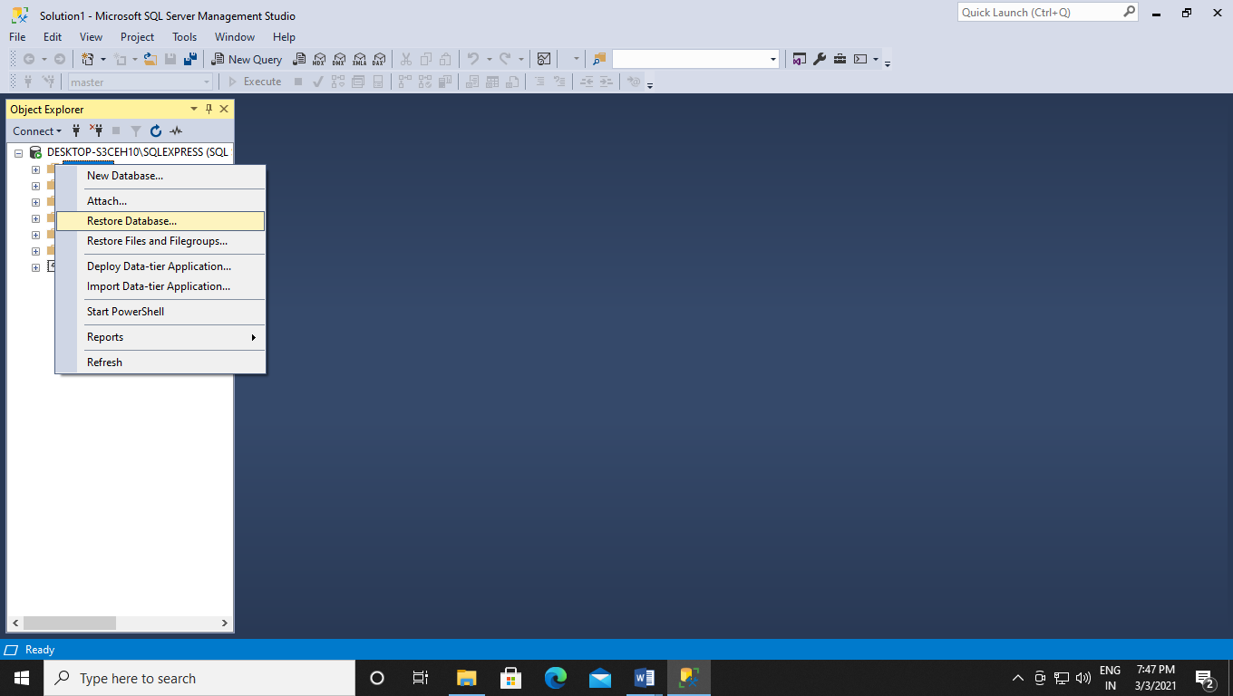

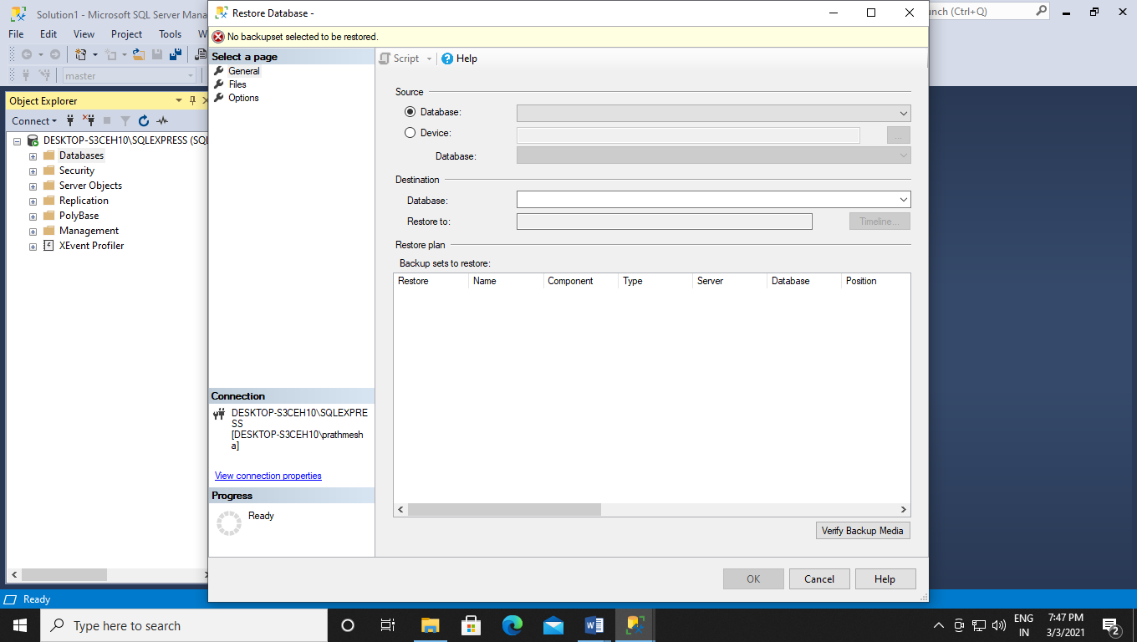

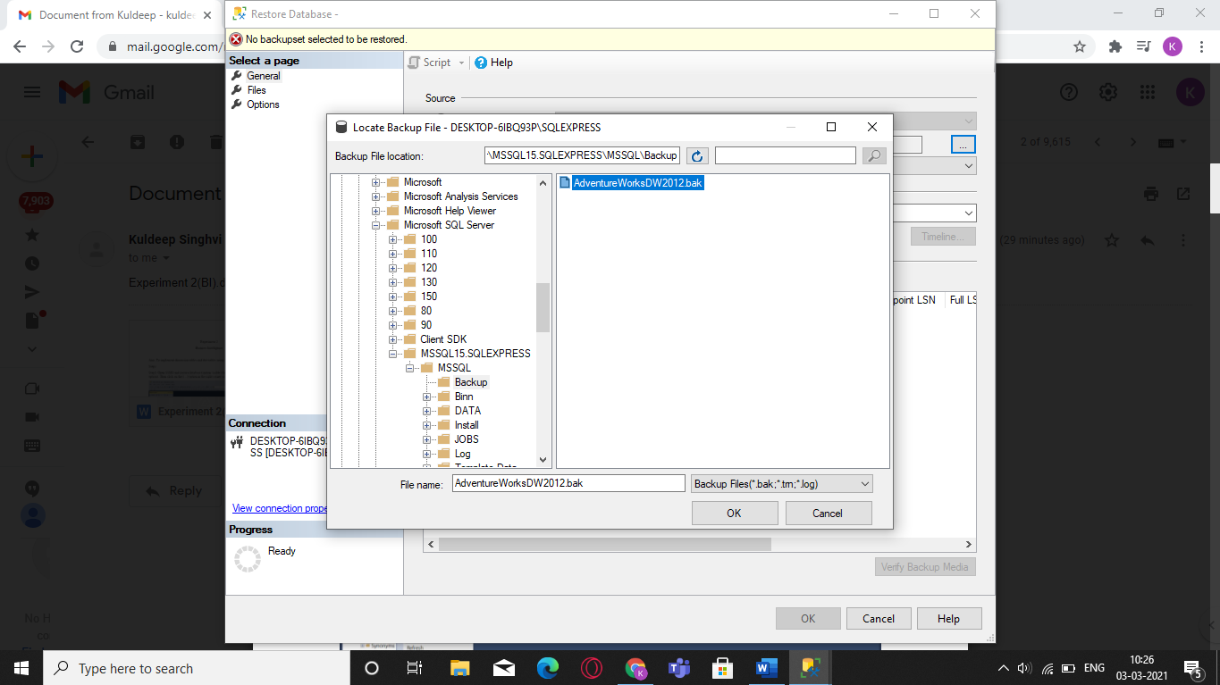

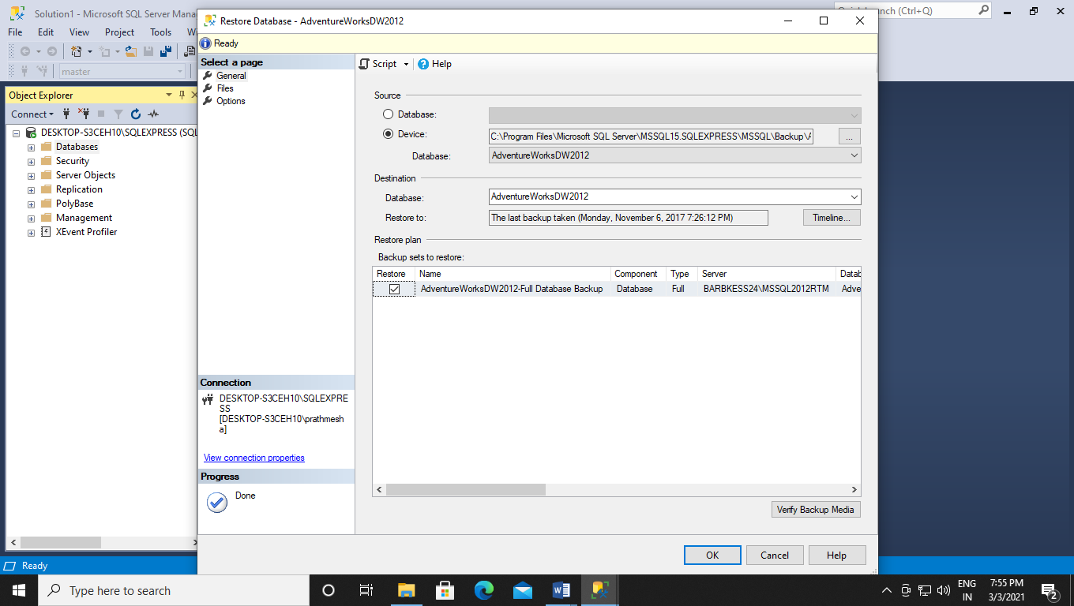

Step 2: Create a new database “data_modeling” through the SSMS and select the menu item

“Databases , data_modeling , Database Diagrams , Install Diagram Support “. The menu

item wouldn’t appear if the diagram support feature were installed.

Step 3: Create a new Database Diagram and then go to programmability and under user

defined data types add the following keys:

a. dbo.udt_business_key (nvarchar (20), not null)

b. dbo.udt_dollar_amount (money, not null)

c. dbo.udt_quantity (int, not null)

d. dbo.udt_surrogate_key (int, not null)

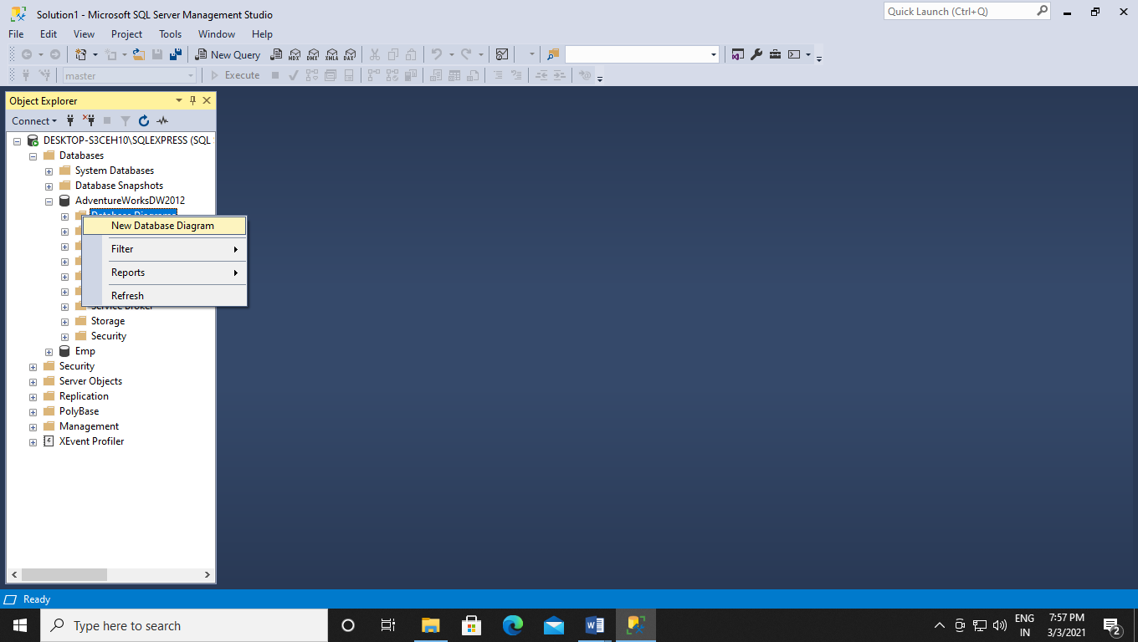

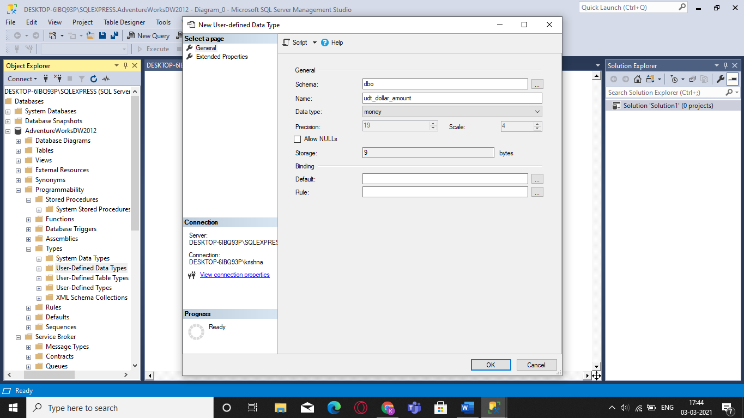

Step 4: Under the file database uploaded, go to tables option and right-click to create a new

table called dim_date.

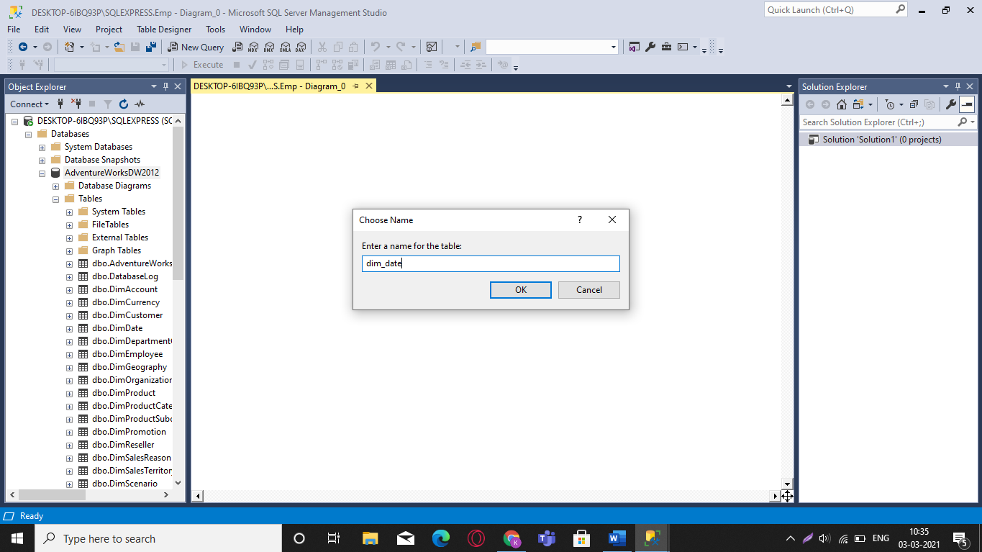

Step 5: Inside the table add the column name “date_key” and add Data Type

“udt_surrogate_key:int” and uncheck the Allow Nulls option. Now repeat the same procedure

of creating tables with the following column names and the following data types. These all

tables created are called the dimension tables. (After naming and detailing each table save the

table and check if the (*) symbol should not be visible).

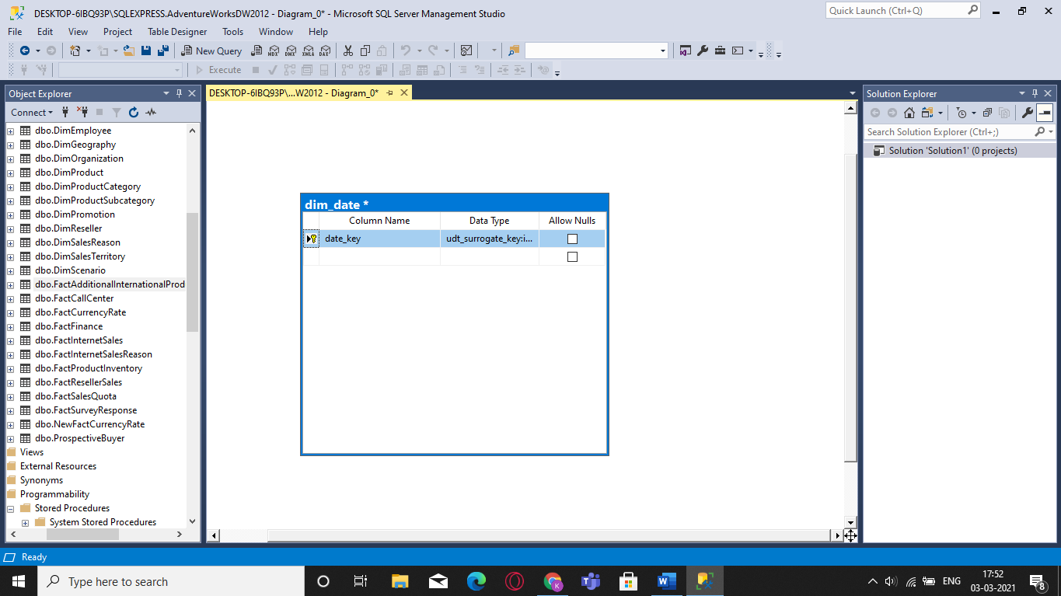

Step 6: Now again create a new table called (Fact_Sales_Order) which is for creating a fact

table and the column names and data types according to the below given image. (Finally after

adding all the values save it),(To have a minimized view right click on the table and inside

view click on name only).

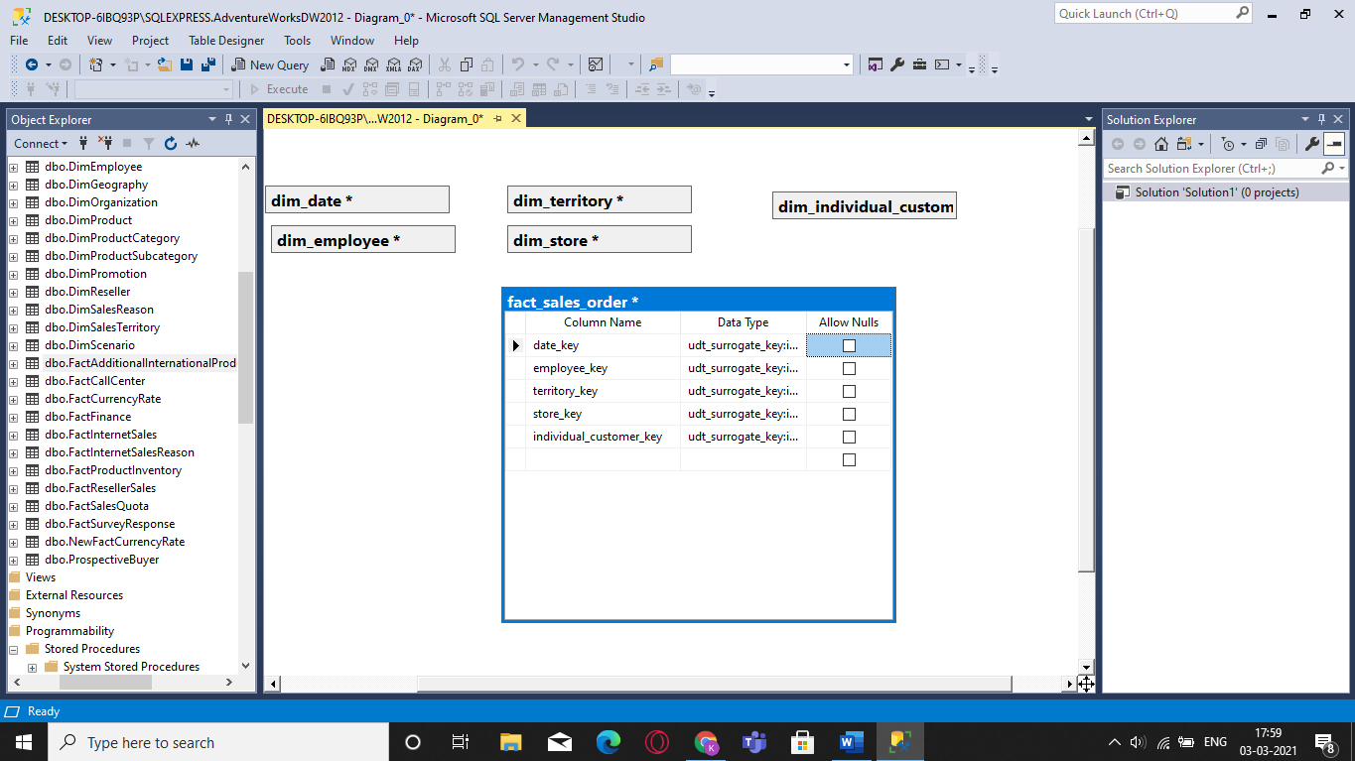

Step 7: After creating all the tables drag each data from each table to its corresponding data

inside the fact_sales_order table. After matching each data right click and select all and then

again right click on a any table. After that press on arrange schema and the desired star

schema should be visible.

